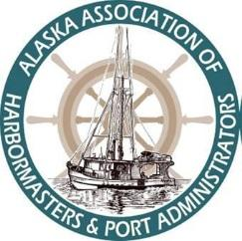
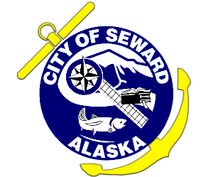
Alaska Association
of Harbormasters & Port Administrators
39th Annual Conference Schedule
October 8 – 12, 2018
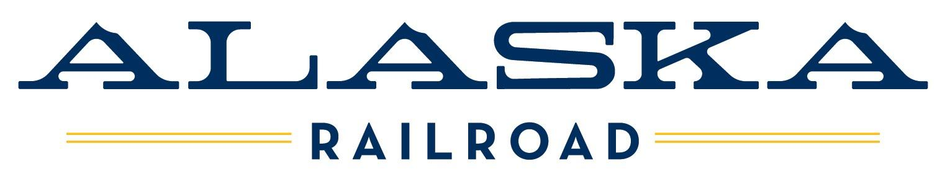

** All activities take place in the K. M. Rae Marine Education
Building (125 3rd Ave., MAP #8) unless otherwise noted **
Monday October 8th, 2018
2:00 - 4:00 PM Conference Registration and Check-In
Chamber of Commerce and Visitor’s Center (2001 Seward Hwy., MAP #1)
5:00 - 7:00 PM WELCOME RECEPTION
Chinooks Seafood and Grill (1404 4th Ave, MAP #3)
Food generously sponsored by Alaska Railroad Corporation
Beverages provided by Global Diving

Tuesday October 9th, 2018

7:15 – 8:00 AM Breakfast
American Legion – Post #5 (402 5th Ave., MAP #5)
Sponsored by R&M Consultants, Inc.
Conference Registration and Check-In
Continued at K.M Rae Building (125 3rd Ave., MAP #8)
8:15 – 8:45 AM Welcome and Opening Comments
AAHPA President and Dignitaries
8:45 – 9:30 AM Sponsor Recognition (Round 1)
- Please state your name and the name of the company you represent.
- How do you or your company provide benefits to Alaska’s ports and/or harbors? (5 min. total)
9:30 – 9:45 AM Break
Sponsored by Pacific Pile & Marine, L.P.
- Breaks are great opportunities to meet with our vendors and ask questions. Please thank them for supporting the association!
9:45 –1:00 PM PORT TOUR via Water and Land (Seward Harbor, ARRC Port of Seward, Seward Marine Industrial Center)
Kenai Fjords Tours (1304 4th Ave., MAP #4)
1:00 – 2:30 PM Executive Board Meeting
Seward Community Library (239 6th Ave., MAP #6)
Sponsored by Bellingham Marine Industries, Inc.
1:00 – 2:30 PM Lunch (on your own)
- Check out local restaurants: The Cookery, Alaska Seafood Grill, Sea Salt Grill
2:30 – 3:45 PM Sponsor Recognition (Round 2)
- Please state your name and the name of the company you represent.
- How do you or your company provide benefits to Alaska’s ports and/or harbors? (5 min. total)
Call of Ports (Round 1)
- Introduce yourself, your team and briefly tell us what’s NEW at your port/harbor (Infrastructure, system or staff).
- What are your biggest challenges or future concerns or how you have solved a shared problem? (5 min total)
3:45 – 4:00 PM Break
Sponsored by TransPac Marinas Inc.
4:00 – 5:00 PM Call of Ports (Round 2)
- Introduce yourself & your team and briefly tell us what’s NEW at your port/harbor (Infrastructure, system or staff).
- What are your biggest challenges or future concerns or how you have solved a shared problem? (5 min total)
5:15 – 7:00 PM Exhibitor Open House
Open to Public With Hors d’Oeuvres
Pick/Sign Up Teams for Evening Activities (See Below)
Seward Scavenger Hunt – gather your team or go for the solo win for this fun game with prizes!
7:00 – 9:00 PM Seward Keel Haul – gather your team or go for the solo win for more fun and games with prizes!

Wednesday October 10th, 2018

7:15 – 8:00 AM Breakfast
American Legion – Post #5 (402 5th Ave., MAP #5)
Sponsored by Moffatt & Nichol
8:15 – 9:00 AM History of Seward’s Waterfront, Kim Nielsen PE—Group Manager of Waterfront Engineering, R&M Consultants
K.M Rae Building (125 3rd Ave., MAP #8)
9:00 - 9:45 AM AVTEC Ship Simulator/AVTEC Maritime Info with Captain Terri Federer
9:45 – 10:45 AM Recent Metocean Studies, Younes Nouri, PhD, Moffatt & Nichol
10:45 – 11:00 PM Break
Sponsored by TransPac Marinas Inc.
11:00 - 11:45 PM DOT Harbor Facility Grants State of Alaska, Jim Potdvein, State of Alaska
11:45 – 12:00 PM Walk to Alaska SeaLife Center (301 Railway Ave., MAP #7)
12:00 – 1:00 PM Lunch with Key-Note Speaker Senator Peter Micciche
Sponsored by Turnagain Marine and HDR Alaska, Inc.
1:15 – 2:15 PM AVTEC Ship Simulator – Group 1
AVTEC (809 2nd Ave., MAP #9)
AVTEC Fire Training Simulator – Group 2
Seward Marine Industrial Center (700 Nash Rd., MAP #12)
2:15 – 2:30 PM Break – Group 1 (SPONSOR)
AVTEC (809 2nd Ave., MAP #9)
2:30 – 2:45 PM Break – Group 2
AVTEC (809 2nd Ave., MAP #9)
2:45 – 3:45 PM AVTEC Ship Simulator – Group 2
AVTEC (809 2nd Ave., MAP #9)
AVTEC Fire Training Simulator – Group 1
Seward Marine Industrial Center (700 Nash Rd., MAP #12)
4:00 – 5:00 PM Annual AAHPA Business Meeting
6:00 – 9:00 PM Conference Annual Banquet
Alaska Railroad Cruise Ship Terminal Building (MAP #10)
Sponsored by PND

Thursday October 11th, 2018
*** Administrators Follow Track Below ***

7:15 – 8:00 AM Breakfast
American Legion – Post #5 (402 5th Ave., MAP #5) (SPONSOR)
8:15 – 9:00 AM New TWIC Rules: Ex-Director Ed Page/Asst. Director Brett Farrell, Marine Exchange
9:00 - 9:45 AM Recent Advances in Port Design Features for Alaska: Dempsey Thieman/Paul Kendall, PND
9:45 – 10:15 AM SB92 bill signing and light refreshments with Governor Walker and Senator Micciche (SPONSOR)
10:15 – 10:30 PM SB 92 Membership Collaboration Thank you – Representative Paul Seaton
10:30 – 11:00 PM ADEC
11:00 – 11:45 PM ALASKA LNG
Project Update and Logistics Specific to Ports/Harbors
11:45 – 1:00 PM Gubernatorial Candidate Presentations – Hosted Lunch (SPONSOR)
1:00 – 2:00 PM Future Cruise Berth Capacity – How to Manage Public Concerns: Josiah Berg/ Josie Wilson, HDR
2:00 – 2:30 PM LNG Ship Conversion Project: Alex Hofeling, TOTE Director of Marketing
2:30 – 3:15 PM Alaska Partnership on Infrastructure Protection: Tom Koloski/James Benzschawel, State of Alaska Division of Homeland Security
3:15 – 3:30 PM Break
Sponsored by Pacific Pile & Marine, L.P.
3:30 – 4:15 PM Earthquake & Tsunami Program – Move or Stay Put?: Dan Belanger, Manager/EMS and Dmitry Nicolsky
4:15 – 5:00 PM USACE Alaska District 2018-2019 Civil Works Program: Bruce R. Sexauer, Chief of the Civil Project Management Branch
5:00 PM Dinner (on your own)

ADMINISTRATIVE TRACK
Seward Community Library, Meeting Room, 1st Floor (239 6th Ave., MAP #6)

10:00 – 10:45 AM Collections: Angela Schwertfeger, City of Seward
10:45 – 11:30 AM TBD
11:30 – 11:45 AM Break
11:45 – 1:00 PM Hosted Roundtable Lunch Contracts/Challenges/Solutions
Sponsored by Kord Information Systems LLC
1:00 – 2:00 PM Kord Information Systems LLC: Annette Kord, CEO
2:00 –3:15 PM Working with your Finance Department: Melody Moline/Sam Hickok, City of Seward
3:15 – 3:30 PM Break
- Join main group for break and final speakers of the day

Friday October 12th, 2018

7:15 – 8:00 AM Breakfast
American Legion – Post #5 (402 5th Ave., MAP #5) (SPONSOR)
8:15 – 9:00 AM Derelict Vessels: Rachel Lord Executive Secretary, AAHPA
9:00 – 10:00 AM Conference Wrap Up: Speakers and Comment Sheets

THANK YOU! SEE YOU NEXT YEAR!

