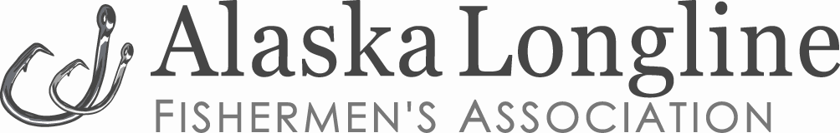

**BE SAFE: STATE OF ALASKA HEALTH MANDATE 017 REQUIREMENTS FOR INDEPENDENT FISHING VESSELS**

State of Alaska Health Mandate 017 enacts health directives for independent commercial fishing vessels larger than skiffs operating in Alaska waters and ports. Health Mandate 017 and forms are available at the following link: <https://covid19.alaska.gov/health-mandates/>. ALFA and UFA also have links to the mandate and other information on our home web pages: <http://www.ufafish.org/> <http://www.alfafish.org/>. Documents that all vessels must carry include Mandate 017 Appendix 01, Appendix 02, a health log and a vessel sanitation plan**.**

* Appendix 01 is the “Alaska Protective Plan for Independent Commercial Fishing Vessels” and has seven sections that cover documents, travel procedures, and health directives for use on-board the vessel and at port. Independent commercial fishing vessels must enact Appendix 01 protective measures and procedures.
* Appendix 02 is the “Independent Fishing Vessel Protective Measures Acknowledgement Form” that vessels must carry throughout the 2020 season.
* Vessel captains must maintain a ship’s log or other electronic document certifying (1) health screening for arriving crew; (2) self-quarantining for crew arriving from outside Alaska and (3) on-board procedures taken should any crew member become ill.
* 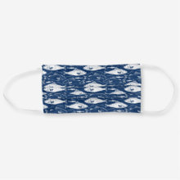Crew or captains arriving via airplane will need to wear cloth face coverings while transiting air terminals, on the plane, and upon arrival in Alaska, to their self-quarantining location.
* Crew or captains in transit must carry documentation showing that they are an essential “Critical Infrastructure Worker” as defined under State Health Mandates.
* Vessels must carry and fly a “Lima” flag when any quarantining crew are on board.
* Captains must maintain a written plan for vessel sanitizing in accordance with Mandate 017.
* 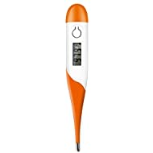Vessels must carry and use thermometers per Mandate 017 directives.
* The state recommends that vessels carry disposable and single use utensils and serving dishes for meals.

Captains must contact a local public health center if a crew member becomes ill with suspected COVID-19 symptoms. The number for the Sitka center is (907) 747-3255.