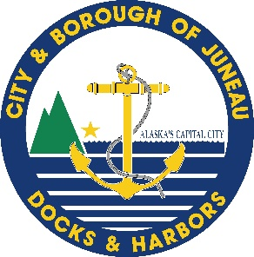ATTENTION MARINERS: COVID-19
If you are experiencing FEVER (>100.3F), COUGH, SHORTNESS OF BREATH, or BODY ACHES, please call (907) 321-1117 for instructions and remain on your vessel.
If you are arriving from outside of ALASKA you are category HIGHER RISK
If you are arriving from outside of JUNEAU you are category MEDIUM RISK
If your trip:
- started in Juneau,
- you are not experiencing symptoms,
You do not need to call and you may proceed to your assigned moorage.
Please follow all State and CBJ recommended mandates.
If you fall into either risk category listed below please proceed as directed.
HIGHER RISK  Health Mandate 10.1 and 11 – Social Distancing  Effective 12:01 am March 25, 2020: All people arriving in Alaska, whether resident, worker or visitor, are required to self-quarantine for 14 days and monitor for illness. Arriving residents and workers must work from home, unless you support critical infrastructure.  If you are not a resident of Juneau, you should:  Remain on your vessel  Call (907) 321-1117 for instructions  If you are a resident of Juneau and are arriving from outside of the state:  - Your quarantine location is your residence.  - Read and follow the Health Mandates.  - Contact your employer and do not go to work or school for this 14-day period after you return. |  | MEDIUM RISK  Health Mandate 12 – Intrastate Travel  If you have traveled to ANY destination outside of JUNEAU, but within the state of Alaska,  If you are not exempt from Health Mandate 12:  Remain on your vessel  Call (907) 321-1117 for instructions  Otherwise you must:  - Read & follow the current Health Mandates  - Minimize contact with people as much as possible, self-monitor and practice social distancing.  - Discuss your work situation with your employer before returning to work.

ADDITIONAL GUIDANCE FOR RETURNING TRAVELERS IN THE HIGHER AND MEDIUM RISK GROUPS
- Take your temperature with a thermometer two times a day and monitor for fever. Also, watch for cough or trouble breathing.
- If you get sick with fever (>100.3 F), cough, or shortness of breath, please call your health care provider.
- Do not take public transportation during the time you are practicing social distancing.
- Avoid crowded places and limit your activities in public.
- Keep your distance from others (about 6 feet or 2 meters).
- If you seek medical care for other reasons, such as dialysis, call ahead to your doctor and tell them about your recent travel.
EVERYONE should follow guidance including regular hand washing, cleaning surfaces, and avoiding large gatherings.
If you have any additional questions, please call (907) 321-1117. The City and Borough of Juneau Docks and Harbors thanks you for your cooperation.

