Alaska Association of Harbormasters

and
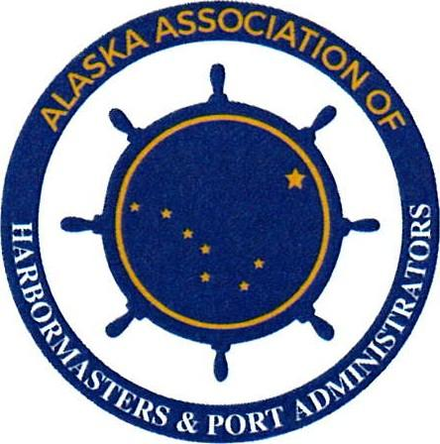
Port Administrators
RESOLUTION NO. 2023-2
A RESOLUTION OF THE ALASKA ASSOCIATION OF HARBORMASTERS AND PORT ADMINISTRATORS IN SUPPORT OF RAISING THE MAXIMUM AVAILABLE ALASKA DEPARTMENT OF TRANSPORTATION HARBOR FACILITY GRANT TO $7,500,000 FOR ELIGIBLE PROJECTS ON AN ANNUAL BASIS.

Whereas, Senate Bill 291 established the Municipal Harbor Facility Grant Program on July 1st, 2006 in which the total amount of grant money made available to a municipality was limited to not exceed $5,000,000 in a fiscal year; and,

Whereas, the Municipal Harbor Facility Grant is the single most significant funding tool available to Alaskan Harbormaster to plan, maintain and recapitalize port and harbor infrastructure; and,

Whereas, testimony from a legislator advocate stated “SB 291 would establish the municipal harbor facility grant fund to which the Legislature would make an annual appropriation from the watercraft fuel tax account and from the state portion of the fisheries business tax. Both sources come from the marine industry so harbor users would generate the revenue for the program”.

Whereas, Senate Bill 291 was envisioned to cap the funds that can be used per community per year at $5 million so that a large community couldn't take all the available funds in any given year. The expectation is that communities would establish, maintain, and run an enterprise fund into perpetuity; and

Whereas, the State of Alaska over the past nearly 30 years has transferred ownership of most of these State-owned harbors, many of which were at or near the end of their service life at the time of transfer, to local municipalities; and

Whereas, these harbor facilities continue to require substantial municipal financial investment to maintain and for capital improvement projects; and

Whereas, construction, shipping and mobilization costs to remote portions of Alaska have outpaced the national consumer price index since the pandemic; and,

Whereas, the United States Bureau of Labor Statistics CPI calculator indicates that $5M in July 2006 when the Senate Bill 291 was enacted would be inflated to $7,511,000 as of July 2023.

Now therefore be it resolved that the Membership of the Alaska Association of Harbormasters and Port Administrators urges the Governor and the Alaska Legislature to amend AS 29.60.800 raising the maximum Harbor facility grant fund award to $7,500,000 per eligible project.

Passed and approved by a duly constituted quorum of the Alaska Association of Harbormasters and Port Administrators on this 28th day of September 2023.

______________________________________
Bryan Hawkins
AAHPA President

ATTEST

______________________________
Angel Holbrook
AAHPA Executive Secretary

